**DAX FUNCTIONS**

MEASURES:

1. Total Unique Artists:

Artists = DISTINCTCOUNT(spotify_history[artist_name])

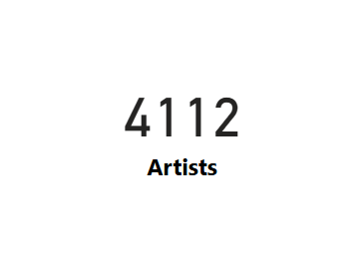

1. Total Unique Albums:

Albums = DISTINCTCOUNT(spotify_history[album_name])

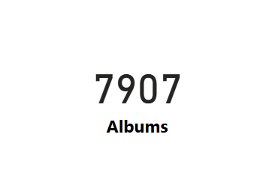

1. Avg Track Duration:

Avg Track Duration = AVERAGE(spotify_history[Minutes])

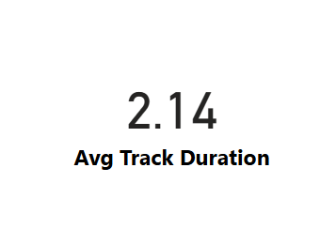

1. Longest Duration Track:

Longest Track =

VAR Summary_Table =

    ADDCOLUMNS(

        SUMMARIZE(spotify_history, spotify_history[track_name]),

        "Total_Minutes", SUMX(FILTER(spotify_history, spotify_history[track_name] = EARLIER(spotify_history[track_name])), spotify_history[Minutes])

    )

VAR MAX_Minute = MAXX(Summary_Table, [Total_Minutes])

    SELECTCOLUMNS(TOPN(1, Summary_Table, [Total_Minutes], DESC),

        "Longest Track", spotify_history[track_name]

    )

1. Skipped Count:

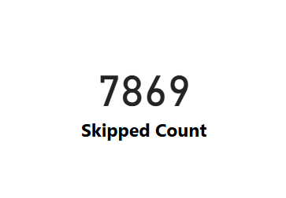 Skipped Count = SUM(spotify_history[Skipped Number])

1. Total Minutes Played:

Total Minutes Played = SUM(spotify_history[ms_played])/(1000*60)

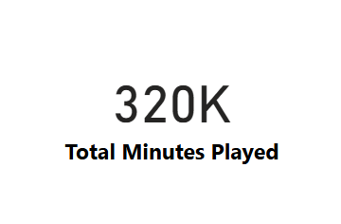

1. Total Tracks Played:

Total Tracks Played = COUNTROWS(spotify_history)

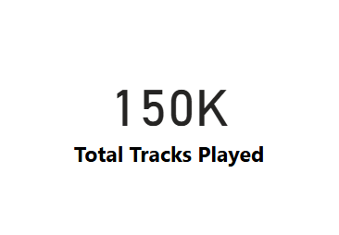

1. Total Unique Tracks:

Tracks = DISTINCTCOUNT(spotify_history[track_name]).

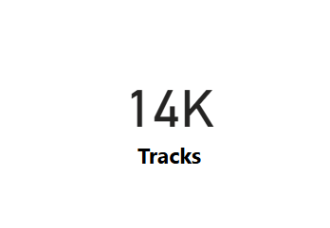

1. YOY Growth 2024 vs 2023:

YOY Growth =

VAR year_2023 = CALCULATE(SUM(spotify_history[track_name]), FILTER(spotify_history, spotify_history[Year] = 2023))

VAR year_2024 = CALCULATE(SUM(spotify_history[track_name]), FILTER(spotify_history, spotify_history[Year] = 2024))

Return

  (year_2024-year_2023/year_2024)

